**MINI PROJECT**

**Title**

Animal Detection using Convolutional Neural Networks (CNN) in Python.

**Objectives**

* To develop a CNN model capable of accurately detecting animals in images.
* To train the model to recognize various animal species with high precision.
* To implement the model in Python using appropriate libraries and frameworks.

**Outcomes**

* A trained CNN model capable of detecting animals in images with high accuracy.
* Demonstrated understanding of how CNNs can be applied to solve real-world problems like animal detection.
* Practical experience in implementing deep learning algorithms for image classification tasks.

**Software**

* Python (version 3.8.5)
* TensorFlow (version 2.4.0)
* Keras (version 2.4.3)
* OpenCV (version 4.5.1)
* Matplotlib (version 3.3.4)
* NumPy (version 1.20.1)

**Theory**

**Convolutional Neural Networks (CNNs)** are a class of deep neuralnetworks, most applied to analysing visual imagery. They have revolutionized the field of computer vision due to their ability to learn features automatically and accurately from images.

* Convolutional Layers: These layers apply convolution operations to the input image, extracting features such as edges, textures, and patterns.
* Pooling Layers: Pooling layers down sample the feature maps, reducing computational complexity while retaining important information.
* Fully Connected Layers: These layers classify the extracted features into different categories (in our case, animal species
* Training and Optimization: CNNs are trained using supervised learning, where they learn to map input images to their corresponding labels. During training, the network's parameters (weights and biases) are optimized to minimize a loss function, such as categorical cross-entropy, which measures the difference between the predicted and true labels. Optimization techniques like stochastic gradient descent (SGD) and its variants are commonly used to update the parameters and improve the network's performance.

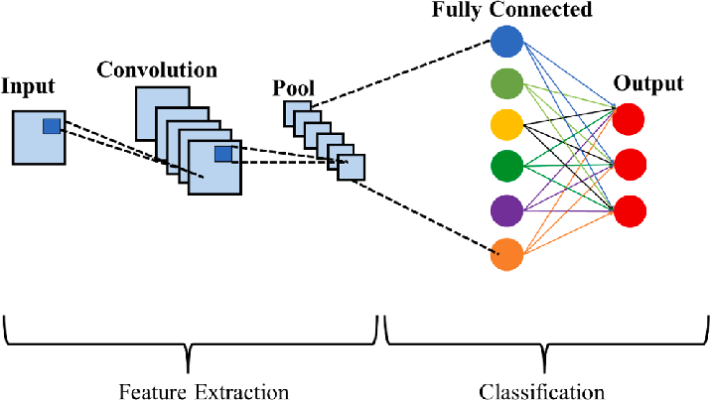

**Fig no. 1. Architecture of CNN**

**For the animal detection problem:**

1. Dataset Preparation: Gather a diverse dataset containing images of various animal species.
2. Data Preprocessing: Resize images, normalize pixel values, and split the dataset into training and testing sets.
3. Model Architecture: Design a CNN architecture suitable for the animal detection task, considering factors like depth, filter size, and activation functions.
4. Training: Train the CNN model using the training dataset and optimize hyperparameters to achieve high accuracy.
5. Evaluation: Assess the model's performance on the testing dataset using metrics like accuracy, precision, recall, and F1 score.
6. Deployment: Deploy the trained model for real-time animal detection in images or videos.

**Algorithm:**

1. Data Collection and Preprocessing:

* Collect a diverse dataset containing images of various animal species. Ensure the dataset is well-labelled.
* Preprocess the images by resizing them to a uniform size, normalizing pixel values, and augmenting the dataset if necessary (e.g., by applying random rotations, flips, or zooms).

2. Model Architecture Design:

* Define the architecture of the Convolutional Neural Network (CNN) model. Consider factors such as:
* Number of convolutional layers
* Filter sizes and strides
* Activation functions (e.g., ReLU)
* Pooling layers (e.g., MaxPooling2D)
* Number of fully connected layers
* Dropout regularization to prevent overfitting.
* Experiment with different architectures and hyperparameters to find the optimal configuration for your dataset.

3. Model Training:

* Split the dataset into training and testing sets.
* Compile the CNN model, specifying the loss function (e.g., categorical cross-entropy) and the optimizer (e.g., Adam).
* Train the model using the training data, adjusting the model parameters through backpropagation.
* Monitor the training process by tracking metrics such as loss and accuracy on the validation set.
* Optionally, use techniques like learning rate scheduling or early stopping to improve training efficiency and prevent overfitting.

4. Model Evaluation:

* Evaluate the trained model on the testing dataset to assess its performance.
* Calculate metrics such as accuracy, precision, recall, and F1 score to measure the model's effectiveness in animal detection.
* Visualize the model's predictions and compare them with the ground truth labels to identify any areas for improvement.

5. Deployment:

* Once satisfied with the model's performance, deploy it for real-world animal detection tasks.
* Integrate the model into applications or systems where animal detection is required, ensuring smooth and efficient operation.
* Continuously monitor the model's performance in production and update it as needed to **maintain accuracy and reliability.**

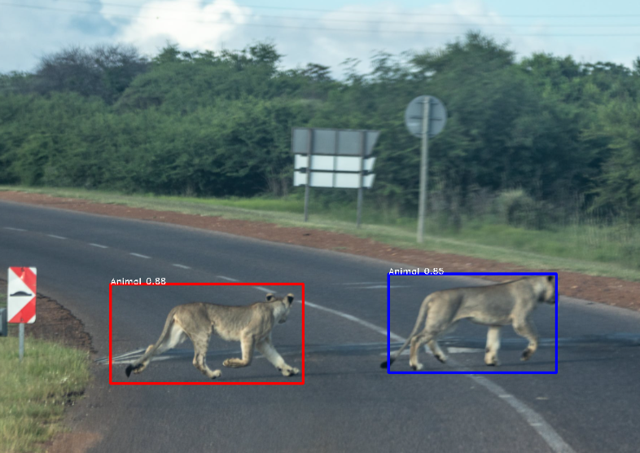

**Fig No. 2. Sample Output**

**Flow Chart**:

**Fig no. 3. Flow Chart for Project**

**Conclusion**

In conclusion, this manual has provided a comprehensive overview of developing a CNN-based animal detection system in Python. By following the outlined steps and utilizing the recommended software libraries, users can create robust models capable of accurately identifying animals in images. Through this project, individuals can gain valuable insights into deep learning techniques for computer vision applications and contribute to solving real-world problems related to wildlife conservation, agriculture, and more.